Udemy Link

[SQL for Beginners: Learn SQL using MySQL and Database Design](https://cognizant.udemy.com/course/sql-for-beginners-course/learn/lecture/8435392#overview)

Handson

DDL Commands - Create, DML Commands - Insert, Select with and without Where condition

Execute the attached script in MySQL Workbench to create Alumni Management System schema.



Refer the ER diagram.

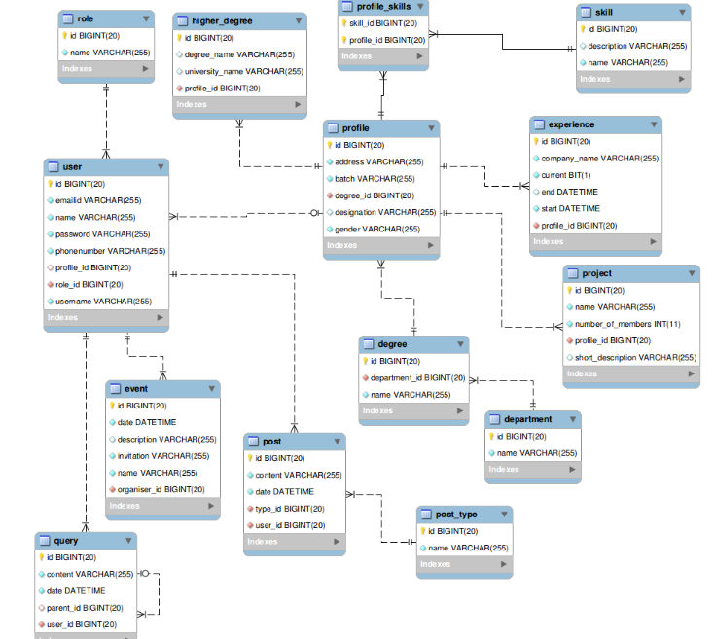

**Write queries for the following DML operations  --- Insert, Update and Delete.**

Insert queries:

* Table role – Insert

Write a query to insert any 2 records into the role table.

* Table event – Insert

Write a query to insert any 2 records into the event table.

Select queries:

* Write a query to display the entire contents of the skill table, sorted by name in ascending order.
* Write a query to display all designations of Female students/alumni from batch 2008 from the profile table sorted in ascending order.

DDL Commands - Alter, Drop, DML - Update and Delete

* Table query – Update

Write a query to update the year in the date entry in the query table from 2012 to 2013.

* Table role – Update

Write a query to change the role name 'Admin' to 'Administrator'

* Table role – Delete

Delete the role 'Student'.

* Table skill – Update

Write a query to change the skill name 'CAD' to 'CADCAM'.

* Table post_type – Delete

Write a query to delete the post_type 'Technology'.

DML - Basic Select Queries II, DML - Inbuilt Functions

* String functions - 1

Write a query to display the name of the users and the length of the names of the users, sorted by the name of the user. Give an alias to the length of the name as length. Use the inbuilt function length().

* String functions – 2

Write a query to display the names of all users that start and end with letter a.

* Select queries II – 1

Write a query to display the number of companies in which the college alumni are currently working in. Give an alias as company_count.

* Select queries II – 2

Write a query to display the number of posts posted in January 2014. Give an alias as number_of_posts.

Normalization, DML - Join Queries, Sub-Queries

* JOIN Queries – 1

Write a query to display the names of the user and the number of posts each user has posted (Give an alias as post_count), sorted by name of the user. Display only the names of users who have posted atleast one post.

* JOIN Queries – 2

Write a query to display the names of the user and the number of events each user has organized (Give an alias as event_count), sorted by name of the user. Display only the names of users who have organized atleast one event.

* JOIN Queries – 3

Write a query to display the entire contents of the table after performing an inner join on role table and user table, sorted by role name and then by name of the user.

* JOIN Queries – 4

Write a query to display the user name and role of all users, sorted by name of the user.

* Subqueries – 1

Write a query to display the contents of queries raised or answered by Ram, sorted by date.

* Subqueries – 2

Write a query to display the contents of posts posted by Ram, sorted by date.